**Project Design Phase-II**

**Technology Stack (Architecture & Stack)**

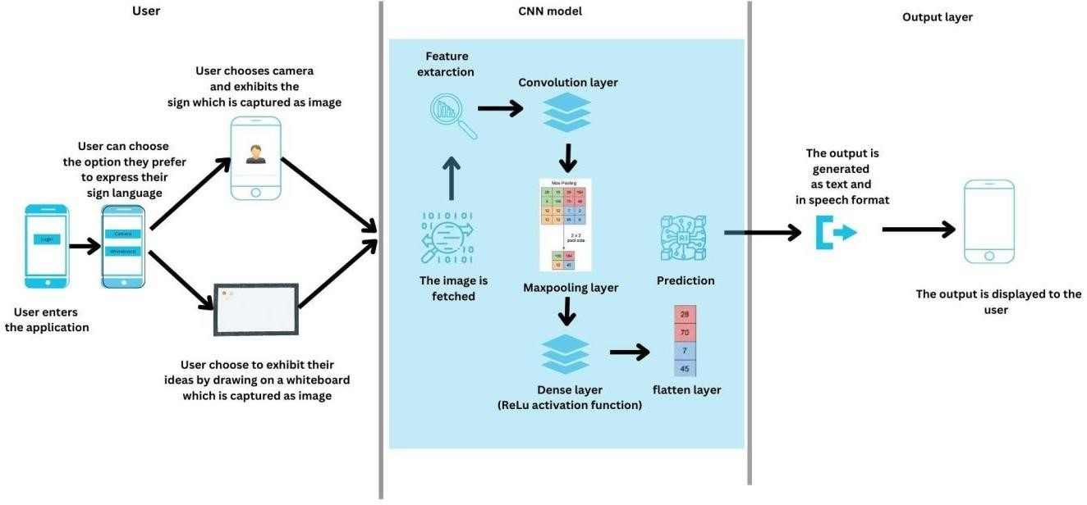

|  |  |
| --- | --- |
| Date | 16 NOVEMBER 2022 |
| Team ID | PNT2022TMIDO6547 |
| Project Name | Project-Real-Time Communication System  Powered by AI for Specially Abled |
| Maximum Marks | 4 Marks |

**Technical Architecture:**

**Table-1 : Components & Technologies:**

|  |  |  |  |
| --- | --- | --- | --- |
| **S.No** | **Component** | **Description** | **Technology** |
| 1 | User Interface | User Interface provides options for the user to either upload a photo or turn on live camera for the prediction of sign language | HTML, CSS,  JavaScript/React JS |
| 2 | Application Logic-1 | The user input is taken and passed on to the model for feature extraction and prediction of the sign language. | Python |
| 3 | Application Logic-2 | The output is produced in speech format using the IBM Watson Text To Speech service. | IBM Watson TTS service |
| 4 | Database | The user login details and credentials are stored and processed using MySQL database. | MySQL. |
| 5 | Cloud Database | We use IBM cloud data storage to store and manage user data. | IBM DB2, IBM Cloudant etc. |
| 6 | Machine Learning  Model | Our Machine learning model is used to predict sign language with precision and accuracy. | Hand gesture recognition, etc. |
| 7 | Infrastructure (Cloud) | Our application is deployed using IBM Watson services | IBM watson services |

**Table-2: Application Characteristics:**

|  |  |  |  |
| --- | --- | --- | --- |
| **S.No** | **Characteristics** | **Description** | **Technology** |
| 1 | Open-Source  Frameworks | Flask web application,  Google colab | * HTML * CSS * Javascript * Flask * Google colab |
| 2 | Security  Implementations | User login credentials and  other details will be  secured Using MD5 encryption and IAM Controls. | MD5, Encryptions,  IAM Controls, OWASP etc. |
| 3 | Scalable Architecture | This project enables the developer to add more templates and it also paves the path to train the model in-case if there is a need to train the model with new sign language. | Technology used  Machine learning |
| 4 | Availability | This is an open source application and it is available to all users and it manage all the customers without any network glitch | Technology used  Flask web application |
| 5 | Performance | This app will quickly upload and process the images because it predicts the sign language using CNN model and it gives high accuracy. | Technology used |